OLLY FILMING SETUP
YouTube Content Production Reference
Style reference: Chris ‘The Wiz’ Miller

Bird’s Eye Setup Diagram
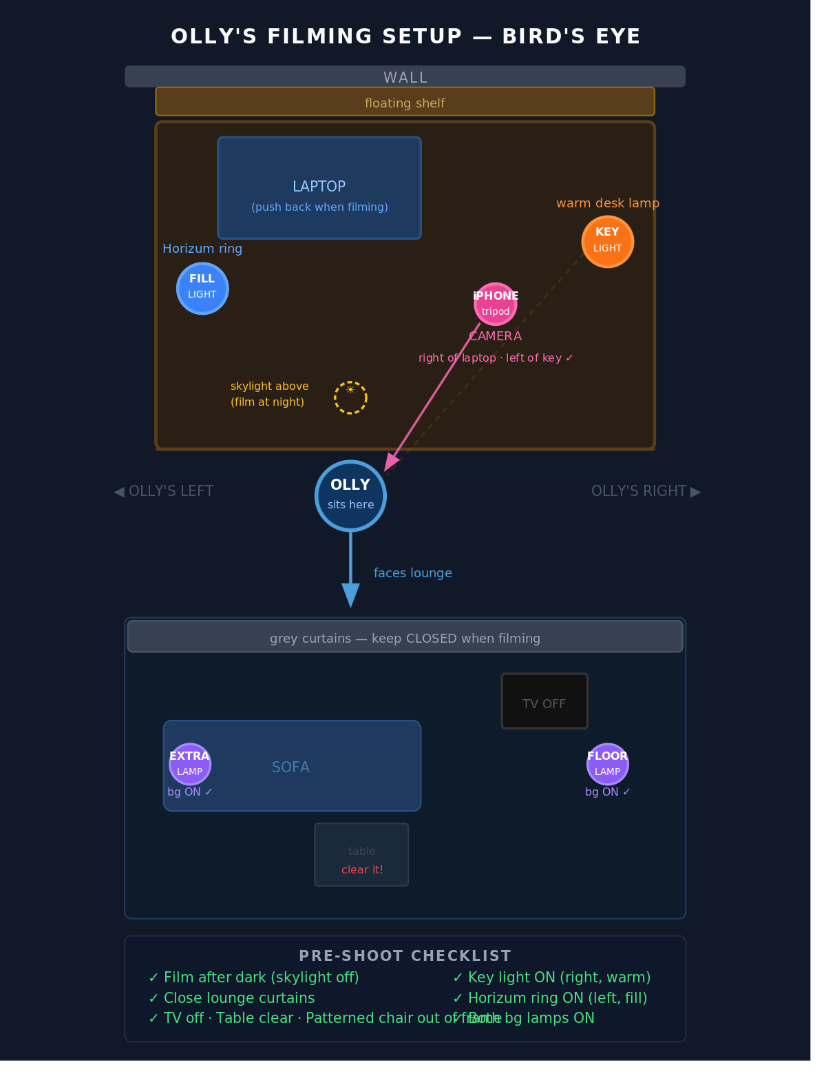

Equipment
Item | Role | Notes
iPhone (recent) | Camera | On black tripod stand — right side of desk
Warm desk lamp | Key light | Olly’s right. Angled at face from side.
Horizum ring light | Fill light | Olly’s left. Dimmer than key light.
Floor lamp (lounge) | Background accent | Right side of lounge. ON when filming.
Extra lamp (lounge) | Background accent | Left side of lounge. ON when filming.

Lighting Notes

Key Light — Warm Desk Lamp (Olly’s right)
- The dominant light. Warm/incandescent bulb.
- Angled toward Olly’s face from the right side.
- Creates shadow on the left side of his face — this is the depth and mood.
- During the day the skylight overpowers it. Film after dark.

Fill Light — Horizum Ring (Olly’s left)
- Softer, cooler light from the left side.
- Should be noticeably dimmer than the key light to preserve shadow and depth.
- Stops the shadow side of the face from going completely dark.

Background Lamps — Floor Lamp + Extra Lamp (lounge)
- Both ON when filming.
- Creates warm ambient glow in background — similar to the vertical accent light Chris The Wiz Miller uses.
- Floor lamp on Olly’s right, extra lamp on Olly’s left.

What to Turn OFF
- Office overhead spotlights — flatten the face, kill depth
- Lounge overhead lights — background should be darker than Olly’s face
- TV — black screen is cleaner than a reflective grey one

Background Notes
- Grey curtains across the back wall — CLOSE every shoot
- Sofa — keep tidy, remove throws or clutter before filming
- Patterned chair on right — move out of frame every shoot
- Coffee table — clear the remote and anything else off it

Pre-Shoot Checklist
Run through this before every recording session.

- Film after dark (skylight off)
- Close lounge curtains
- Turn off office overhead spotlights
- Turn off lounge overhead lights
- TV off
- Coffee table cleared
- Patterned chair moved out of frame
- iPhone on tripod — right side of desk, right of laptop, left of key light
- Key light on (warm desk lamp) — angled at face from right
- Horizum ring on — left side, dimmer than key
- Both background lamps on (lounge)
- Sit down and check framing before recording

The Skylight Issue
There is a skylight directly above Olly’s head at the desk. In daylight, it overpowers all artificial lighting and creates flat, shadow-free light on the face — the opposite of the moody look.

Solutions:
- Film in the evening or at night — free, immediate, fully effective
- Install a blackout skylight blind (Velux or generic, £30–80) — enables daytime filming
- Upgrade to a stronger LED panel key light (Elgato, Godox) that can overpower daylight — more expensive

